GLANDS
ى

A gland is an organ of secretion made of specialised secretory cells derived from surface epithelium on which it opens.

GENERAL FEATURES
- Glands can be present as discrete organs or in the layers of viscera.
- The secretory cells of the glands form functional units called secretory end pieces, which are either ﬂask shaped (acini) or cylindrical in shape (tubules).
- It is epithelial in origin.
- The ﬂuid secreted by the gland contains enzymes, hormones, mucus or fat.
- The rate of secretion is modulated by nervous and hormonal inﬂuences.
- The secretory end pieces of some exocrine glands are surrounded by star-shaped contractile cells that lie between the secretory cells and the basement membrane. They are called myoepithelial cells as they share characteristics of both epithelial and muscle cells.

DEVELOPMENT
- Glands arise as invagination of the epithelium into the underlying vascular connective tissue.
- The distal part of the invagination forms the glandular portion or secretory end piece, which is functionally an active portion.
- The proximal part forms the excretory duct which opens on the surface of the epithelium from which it is developed.
- Some cells get detached from the epithelial surface and form ductless glands or endocrine glands.

CLASSIFICATION OF GLANDS

- Based on the site of secretion
  - Exocrine gland – secretes its products onto a surface through ducts, e.g. salivary glands.
  - Endocrine gland – secretes its products into the bloodstream, e.g. thyroid glands.

- Based on the number of cells
  - Unicellular gland – composed of a single cell, e.g. goblet cells in the respiratory and intestinal tracts.
  - Multicellular gland – composed of many cells, e.g. all glands other than goblet cells.
- Based on the number of ducts and shape of secretory end piece
  - Simple gland – has one duct.
  - Compound gland – has minor and major ducts.
The types of simple and compound glands are illustrated in Flowchart 3.1.

37

Excretory duct

Secretory end piece

Fig. 3.1 Development of glands.
- Based on the mode of secretion
  - Merocrine gland – secretory cells release their contents by exocytosis (no loss of cytoplasm), e.g. most of the compound glands.
  - Apocrine gland – apical part of the cytoplasm of the secretory cells is lost in the process of secretion (partial loss of cytoplasm), e.g. lactating mammary gland, sweat gland in the axilla and external genitalia.
  - Holocrine gland – secretory cells burst out pouring their contents, resulting in the death of the cells (complete loss of cytoplasm), e.g. sebaceous gland, tarsal gland.
  - Cytocrine gland – cells are released as secretion, e.g. testis (spermatozoa).
- Based on the nature of secretion
  - Serous gland – secretes thin watery material rich in enzymes, e.g. parotid salivary gland (Fig. 3.2; Box 3.1).

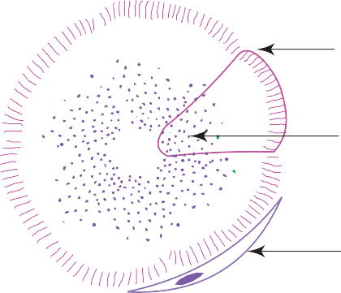
Basal lamina

Zymogen granules

Myoepithelial cell

Fig. 3.2 Serous acinus.

Glands

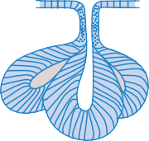
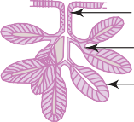
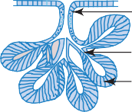
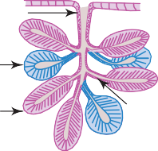
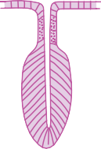
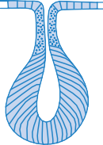
- Unbranched, e.g. urethral gland
- Branched, e.g. sebaceous gland, tarsal gland
Acinar (alveolar)
- Straight, e.g. intestinal crypt
- Branched, e.g. uterine gland fundic and pyloric glands of stomach
- Coiled, e.g. sweat glands
Tubular
Minor duct
Tubule
Tubuloacinar, e.g. sublingual and submandibular glands

Major duct

Acinus
Acinar, e.g. parotid gland

Major duct

Minor duct Acinus
Tubular, e.g. cardiac gland of stomach, Brunner’s
gland of duodenum
Major duct Minor duct Tubule
Compound
Simple

Flowchart 3.1 Classiﬁcation of glands, based on the number of ducts and shape of secretory end pieces.

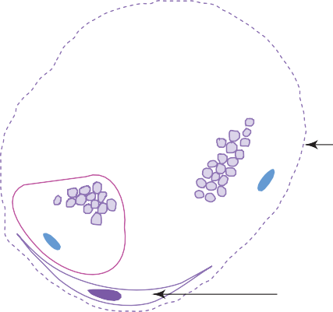
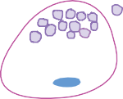
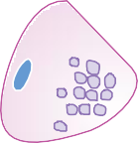
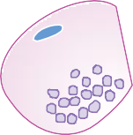
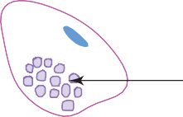
Mucigen droplets

Basal lamina

Myoepithelial cell

Fig. 3.3 Mucous acinus.

Box 3.1
Serous Gland (Parotid Salivary Gland).
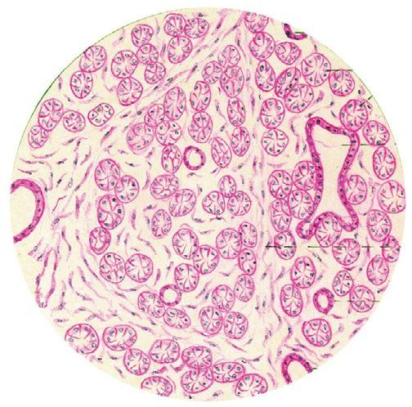
Presence of

Serous Acini

Round Central Nucleus Striated Duct

Interlobular Connective Tissue Septum
Intercalated Duct

Interlobular Duct

Ugtqwu incpf *Rctqvif ucnixct{ incpf+
    - darkly stained serous acini with
narrow lumen;
    - round, centrally placed nuclei in the serous cells;
    - well-developed duct system.

  - Mucous gland – secretes thick viscous material for protection and lubrication, e.g. sublingual salivary gland (Fig. 3.3; Box 3.2).
  - Mixed gland (seromucous) – secretes watery and viscous material from both, serous and mucous acini, e.g. submandibular salivary gland (Box 3.3; Fig. 3.4).
The distinguishing features of serous and mucous acini are presented in Table 3.1.

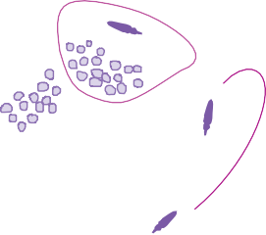
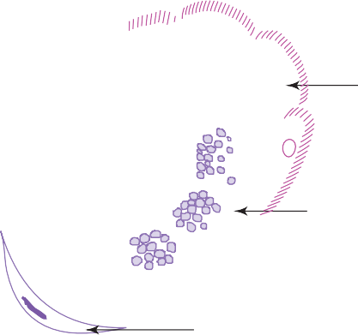
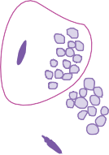
Serous demilune

Mucous acinus

Myoepithelial cell

Fig. 3.4 Seromucous acinus (mixed).

Mucous Gland (Sublin-

Flat Peripheral Nucleus

Mucous Acinus Interlobular Septum
Serous Demilune Interlobular Duct
Serous Acinus

Striated Duct

Oweqwu incpf *Uwdnipiwcn ucnixct{ incpf+
Box 3.2
gual Salivary Gland).
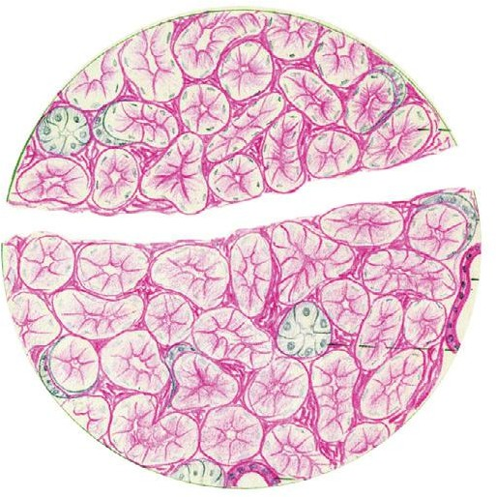
Presence of
    - lightly stained mucous acini/tubules with large lumen;
    - ﬂat, peripheral nuclei in the mucous cells;
    - poorly developed duct system.

Box 3.3
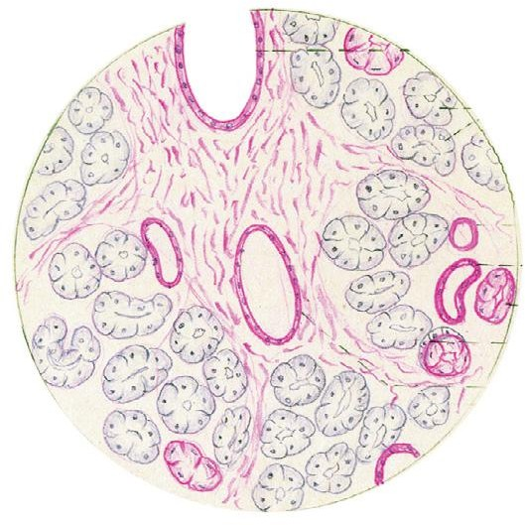
Presence of

Interlobular Duct Serous Acini

Striated Duct Mucous Duct Serous Demilune Interlobular Duct

Oizgf incpf *Uwdocpfidwnct incpf+

Mixed Gland (Submandibular Gland).

- both darkly stained serous and lightly stained mucous acinus;
- serous demilune (crescent-shaped patch of serous cells);
- moderately developed duct system.

Table 3.1 Differences between serous and mucous acini

Diagram

Serous acinus Mucous acinus

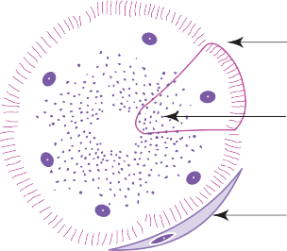
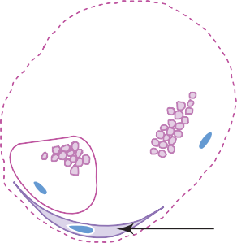
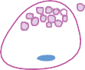
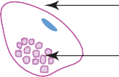
Basal lamina

Zymogen granules

Basal lamina Mucigen droplets

Myoepithelial cell

Consistency for secretion Thin watery Thick viscous

Myoepithelial cell

Nature of secretory granules
Shape and position of nucleus
Zymogen granules Mucigen droplets

Round, central Flat, peripheral

Size of lumen Small Large

Appearance of cell boundaries
Staining reaction with haematoxylin and eosin
Indistinct Distinct

Darkly stained Lightly stained

Functions Enzyme action Protection and lubrication
Example Parotid gland Sublingual gland

GENERAL ARCHITECTURE OF A COMPOUND GLAND
- Most glands are composed of either serous or mucous secretory cells or are of both types. These cells form secretory end pieces which are ﬂask shaped (acini) or cylindrical (tubules) in shape. The end pieces are often associated with contractile myoepithelial cells, whose function is to express the secretion.
- The secretory end pieces and their associated ducts of the gland form parenchyma.
- The connective tissue framework of the gland which supports the parenchyma forms the stroma.
- Parenchyma is composed of
  - secretory end pieces (acini/tubules/tubulo-acini)
  - ducts (intralobular, interlobular, main excretory duct).
- Stroma is composed of
  - capsule
  - septae (interlobular, interlobar)
  - loose intralobular connective tissue supporting the parenchyma.
Malignant tumours arising from glandular epithelial tissue are called adenocarcinomas.

Self-assessment Exercise

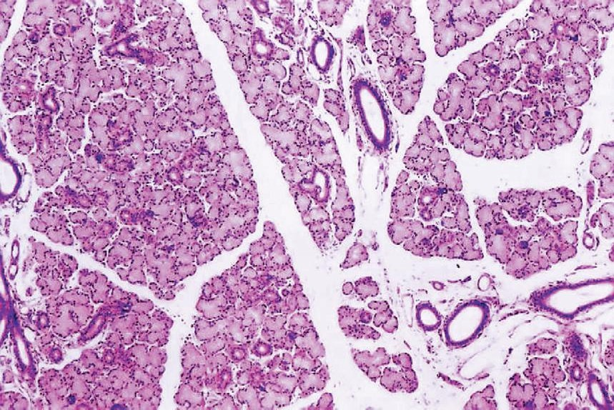
Z62
Id
Lo
Is
Lo
Id
Ma
Lo
Ma
Is
Is
Id
Lo
Is
Ed
Lo
Id
c
Salivary gland.
Examine a section of salivary gland under scanner (Plate 3:1a) and appreciate the general architecture of the gland.
Plate 3:1a

  - Note the ﬁbrous capsule surrounding the gland sending interlobular septae (Is) divid- ing it into many lobules (Lo).

Practical No. 3
Glandular Epithelium: The Salivary Glands
  - Identify the larger excretory ducts (Ed) and medium-sized interlobular ducts (Id) in the septum and the small eosinophilic in- tralobular ducts and lightly-stained secretory acini (Ma) in the lobule.

45

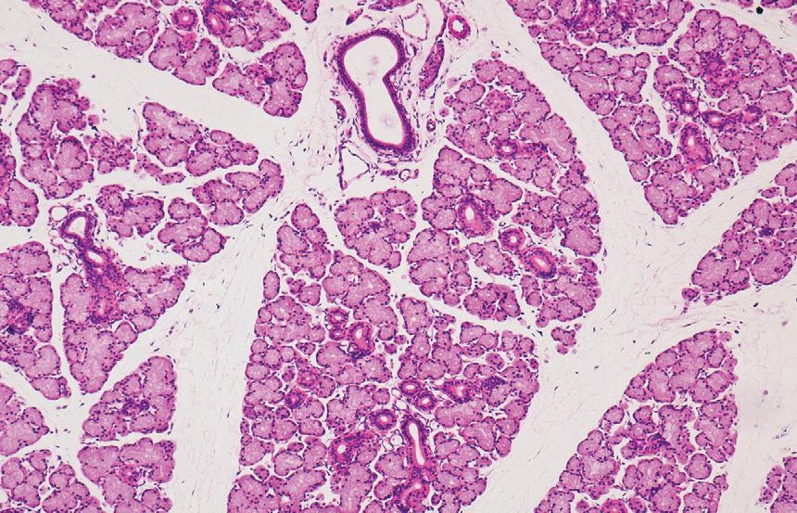
X100
Id
Ma
In
Is
Is
d

Mucous gland (e.g. sub- lingual salivary gland).
Plate 3:1 b and c
At low and high magniﬁcations (Plate 3:1b and c), observe the secretory end piece (mucous acinus) and note its features:

X400
- Lightly-stained cuboidal mucous cells, form- ing mucous acinus (Ma).
- Flat peripherally-placed nucleus (N) in each cell.
- Large lumen of the acinus – can be easily identiﬁed.
- Some mucous acini are associated with darkly stained crescentic patch of serous cells called serous demilune (Sd).

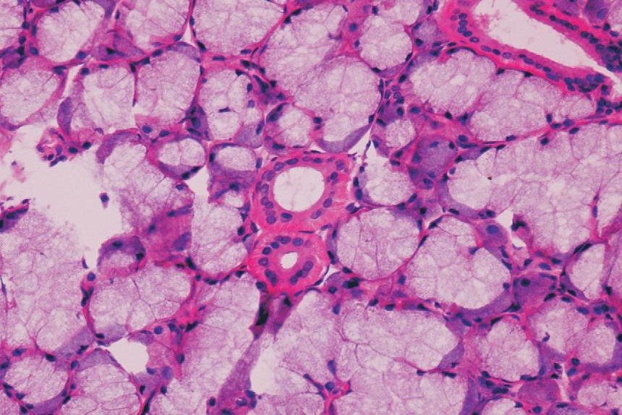
Among the acini identify the large eosin-stained intralobular ducts (In; striated or secretory ducts) lined by simple columnar epithelium and the small intercalated ducts lined by cuboidal epithelium.
Ma
In
In
Ma
Sd
N
e

The striated ducts exhibit basal striations which are due to the basal infoldings of plasma membrane and longitudinal orientation of mitochondria (characteristics of an ion transporting cell). These ducts secrete potassium into primary saliva and absorb sodium making the isotonic primary saliva, hypotonic. They also secrete immunoglobulin A.

X100

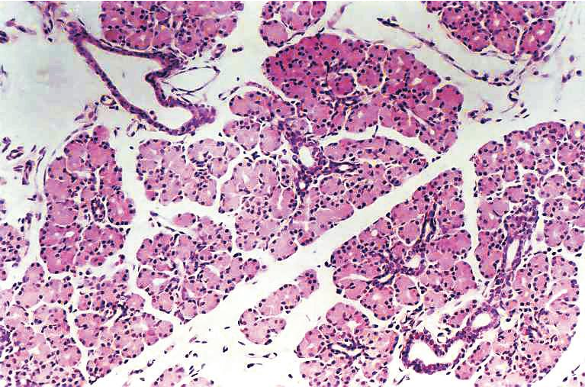
Plate 3:2
Is
Id
Sa
In
Sa
Is
In
Sa
In
c
Serous gland (e.g. parotid gland).
a and b
At low magniﬁcation (Plate 3:2a), observe the architecture of the gland.
Note the intercalated duct (Ic); intralobular duct (In); interlobular duct (Id); interlobular septum (Is).
At high magniﬁcation (Plate 3:2b), observe the secretory end piece (serous acinus) and note the following features:

X400
- Darkly-stained pyramidal serous cells forming
serous acinus (Sa).
- Round centrally-placed nucleus (N) in each cell.
- Small lumen of the acinus; lumen is very small
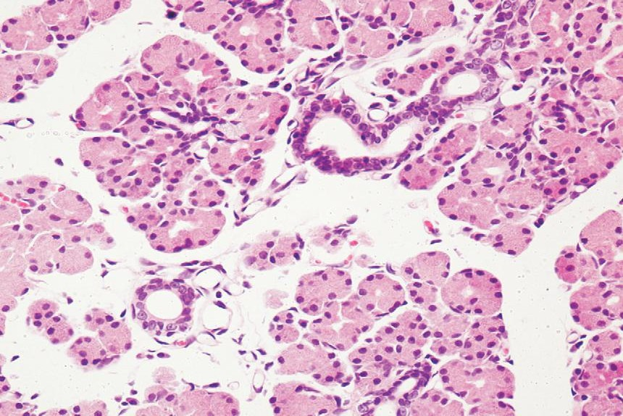
and may not be visible.
Sa
In
Ic
N
Sa
d

Note the small intercalated duct (Ic) arising from the acinus. These ducts end in striated duct (In).
Compare this slide with the previous one and note the differences between serous and mucous acini (refer to text).

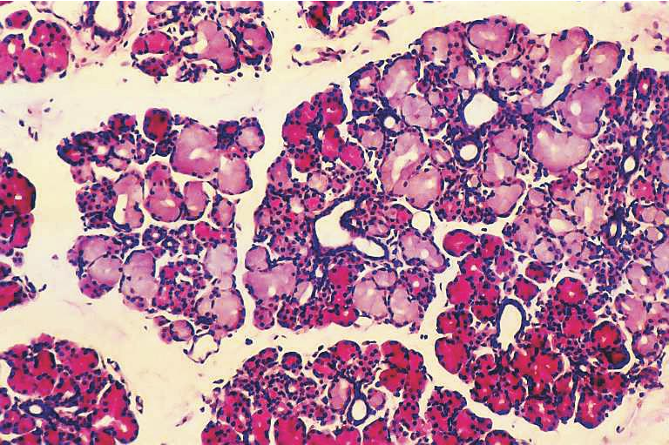
X100
In
Ma
Ma
In
Sa
Sa
c

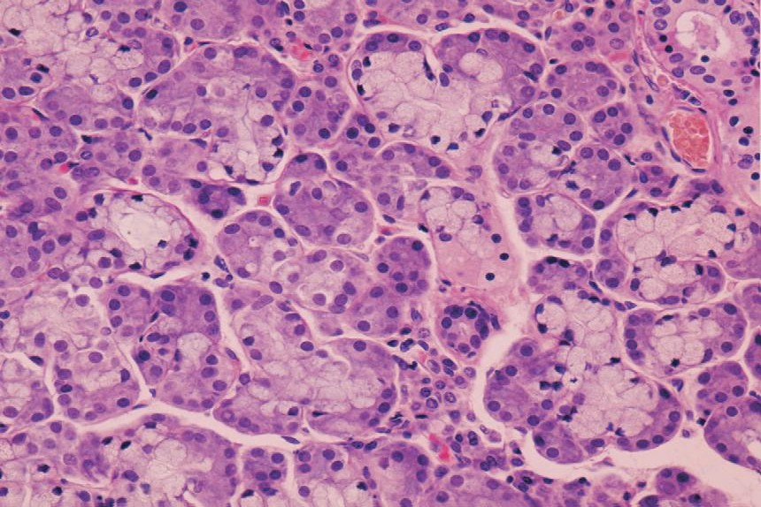
X400
In
Sa
Ma
Ma
Sa
Sd
Sd
d

Plate 3:3
a and b
Mixed gland (e.g. sub- mandibular salivary gland).
At low magniﬁcation (Plate 3:3a) appreciate the architecture as well as mixed nature of the gland.
It shows darkly-stained areas made up of serous acini (Sa) and lightly-stained areas made up of mucous acini (Ma). (Do not confuse adipose tissue for mucous acini.) Intralobular ducts (In) are seen among acini.
At high magniﬁcation (Plate 3:3b), observe the secretory end pieces (serous acini, mucous acini, serous demilunes) and note their features:
- The serous (Sa) and mucous acini (Ma) can be identiﬁed by their staining reaction, size of lumen, and shape and position of nuclei as stated in the text.
- The mucous acini are often associated with darkly-stained, crescentic patch of serous cells called serous demilune (Sd) of Giannuzzi. Identify this semilunar serous demilune ad- herent to a mucous acinus.

Exercise
Compare the slides of salivary glands (Plates 3:1 to 3:3) and enumerate their salient features.
Characteristics of salivary glands: sublingual, parotid and submandibular

Sublingual Parotid Submandibular

Mixed gland but predominantly made of mucous acini
Purely serous gland Mixed gland but predominantly made of serous acini

Compound tubuloacinar gland Compound acinar gland Compound tubuloacinar gland

Poorly developed duct system Well-developed duct system
(mainly striated ducts)
Moderately developed duct system

Very few adipose cells More inﬁltration of adipose cells Moderate number of adipose cells

Thick viscous secretion protective and lubricative in function
Constitutes 5% of volume of saliva
Secretes thin watery secretion rich in enzymes and antibodies (IgA)
Secretion constitutes 25% of volume of saliva
Intermediate in consistency

Constitutes 70% of volume of saliva

